Medicare Moments
presented by Advantage Aging Solutions
and SHINE (Serving Health Insurance Needs of Elders)

Medicare Open Enrollment Part II: Choosing A New Plan

Did you know that Medicare’s annual Open Enrollment Period is the one time of year that most beneficiaries make changes to their coverage? If you have reviewed your present plan, are aware of coming changes that will affect you, foresee increased out of pocket expenses, and have decided to look at other plans, you’ll want to know where to obtain the best healthcare coverage and at the lowest cost.

Changes You Can Make during Open Enrollment:
- Move from Original Medicare to a Medicare Advantage Plan or vice versa
- Move from one Medicare Advantage plan (Part C) to another
- Move from one Medicare prescription plan (Part D) to another
- Join a Part D plan (a late enrollment penalty might apply)
- Drop your existing Part D coverage altogether

To Find a Plan that is Best for You Go to Medicare.gov
- Learn about Original Medicare (Parts A & B) benefits.
- Use the Medicare plan finder and compare similar plans side by side such as Medicare Advantage plans, Prescription drug plans, Medigap (Medicare Supplement Insurance) policies, Part D & Medigap
- Seek the help of a trained SHINE Medicare Counselor, who will:
  - Research Medicare and find answers for you
  - Assist with plan comparisons so you can choose the best plan that fits your needs
  - Explain programs that could save you money on premiums and prescriptions
  - Guide you through enrolling in a new plan


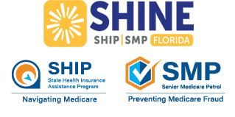

To talk to a SHINE Medicare Counselor, call the Elder Helpline at 866-467-4624

